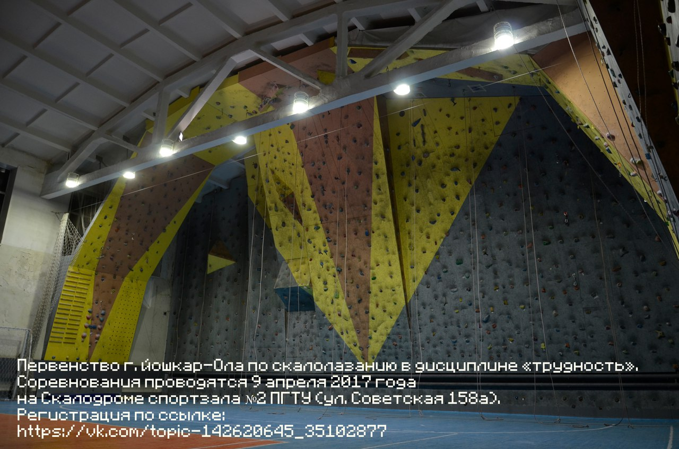
vk.com/topic-142620645_35102877

